Moon S. Jo

Introduction to Data Science:

Class Project I

DotA Outcomes Based on Team Statistics

Professor D. Gutierrez

UCLA Fall ‘19

**Preface**

**About DotA 2**

DotA 2 (Defense of the Ancients) is a video game of two teams, the Radiant and the Dire, each with five players, trying to destroy one another’s base. Each player chooses one of 117 heroes with different magical abilities and roles. A comparison can be made to a chess game where each piece (a player) holds a different capability of attack (role), and the pieces are used in combination to take out the opponent’s pieces. (see Fig. 1 and Fig. 2)

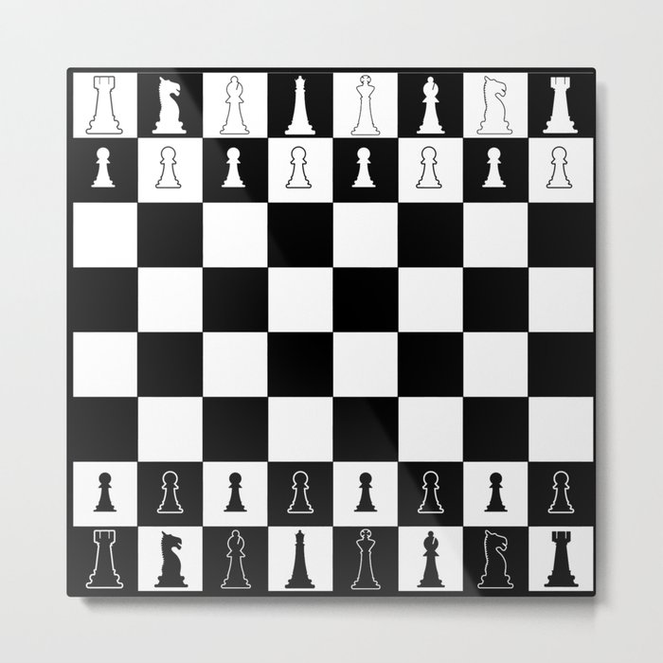 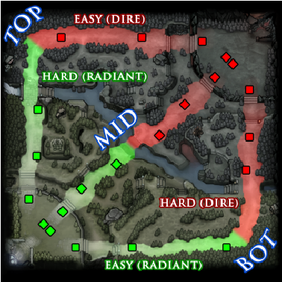

Figure 1. A layout of a chess board and a DotA 2 map.

Here is the list of **roles**, as defined in the DotA 2 Liquipedia1:

*Carry* - Will become more useful later in the game if they gain a significant gold advantage.

*Nuker* - Can quickly kill enemy heroes using high damage spells with low cooldowns.

*Initiator* - Good at starting a team fight.

*Disabler* - Has a guaranteed disable for one or more of their spells.

*Durable* - Has the ability to last longer in teamfights.

*Escape* - Has the ability to quickly avoid death.

*Support* - Can focus less on massing gold and items, and more on using their abilities to gain an advantage for the team.

*Pusher* - Can quickly siege and destroy towers and barracks at all points in the game.

*Jungler* - Can farm effectively from neutral creeps inside the jungle early in the game.

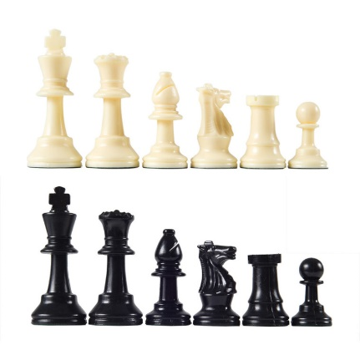 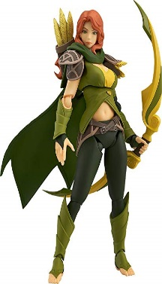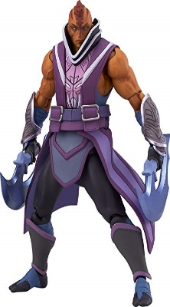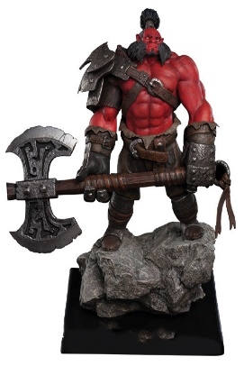

Fig. 2. Chess pieces and DotA 2 heroes. Each piece has different abilities that can fulfill different roles.

One difference between chess and DotA is that in the latter, players can progress during the game by eliminating enemy players and killing monsters that spawn throughout the map. They earn gold and experience points which can be used to purchase items that make them stronger and learn more powerful abilities, respectively. Once they are strong enough, they can take down enemy towers that protect the Ancient, and eventually the Ancient itself to win the game.

This paper discusses how the statistics of the team can be used to predict how likely they are to win a game. I explain my process of considering solely team composition and adding more factors to improve the accuracy of the predictions.

**Method**

I used the R programming language to conduct this analysis.

**Part 1**

**Can I Predict the Outcome of a DotA 2 Game Given the Teams’ Composition of Characters?**

* 1. **Why is team composition important?**

An ideal way a team fights against the other is its initiator starting the fight, the disabler disabling the opponents, and the carry and nuker dealing damage to take them down while the support helps them by making them stronger or the opponents weaker. Therefore, is very important to pick heroes so that they can fill specific roles (See the preface for details). Sometimes, the players only pick carries because they are meant for the most action. They forgo the ability to absorb damage or disable the opponent. This means that although they can shine in duels, they cannot work well during team fights.

* 1. **How would I measure team composition?**

On the DotA 2 Wiki page2, there is a page for every hero. Under its “Gameplay” section, there is a list of roles the hero can play. I assign 1 point for every role, for every hero on the team (see Fig.3).

[,1] [,2] [,3] [,4] [,5] [,6] [,7] [,8] [,9]

Puck 0 0 1 1 0 0 1 0 1

Lich 0 0 0 1 1 0 0 1 1

Pugna 1 0 0 0 0 0 1 0 0

Night Stalker 1 0 1 1 0 1 0 0 1

Lycanthrope 1 0 0 0 1 1 1 1 0

Fig. 3. The role sheet for a team. The columns correspond to roles; the rows have hero names the players picked.

I take the variance, according to this formula:

There are 9 roles, so there would be 9 numbers to add, and a 9 to divide the sum; represents the number of heroes that can play the role in the team; represents the mean of the roles for the team – the sum of all the numbers divided by the number of possible roles.

If a team has characters that can only play similar roles, the variation (team composition score) will be high because the sum for every role will be far from the mean. In that sense, a team with characters that can play many different roles will have a low variation.

* 1. **Hypothesis**

The data had results from the Radiant’s perspective (Radiant Win = True / False). Therefore, I believe that:

The lower the Radiant’s team composition score is compared to the Dire’s, the more likely it is to win.

**Part 2**

**Acquire the Data**

**2.1 Search**

I went to the UCI Data Repository3 as suggested during lecture.

**2.2 Feature Engineering**

I found a data set containing about 10,000 games played on August 13th, 2016.

Here is the list of features contained in the data:

* Which team won the game
* Location ID
* Game Mode (e.g. All Pick)
* Game Type (e.g. Ranked)
* List of characters, and which ones were picked

The list of characters had columns that each represent a character by ID and a boolean value, 1 for picked and 0 for not picked. There are more than a 100 characters, so I transformed this part of the data to be more concise and accessible by creating a chart with the characters and their roles. I used this chart to calculate the team composition score for each team for every game. I subtracted the dire’s score from the radiant’s score and created the “team composition difference” feature.

**Part 3**

**Explore the Data**

**3.1 Plot**

I charted the Radiant’s team composition score disadvantage by the game outcome (see Fig. 3).

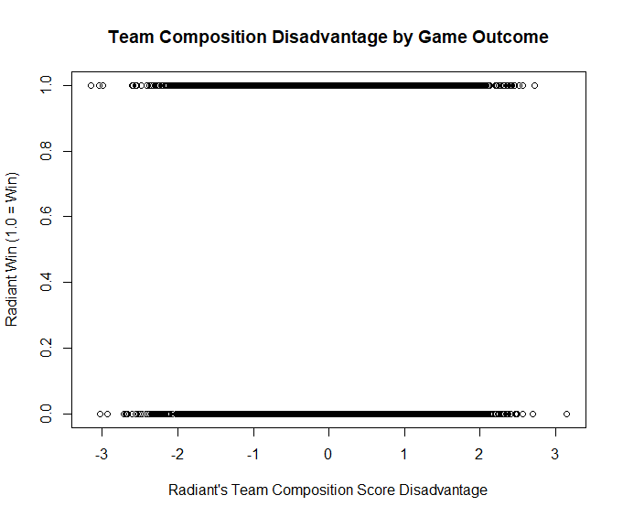

Fig.3

There is no clearly visible relationship between the two variables. Most of the data points are overlapping each other especially in the middle area, so I used a boxplot that could showcase the degree of the overlap.

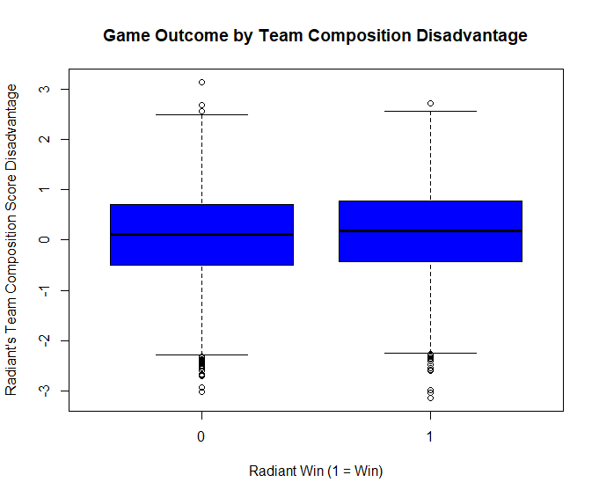

Fig. 4. Boxplot of the same data.

There still isn’t a clear trend in the relationship between the two variables.

In order to explore the predictive capability of machine learning, I’ve decided to use other variables that I believe are impactful in the game.

**Part 4**

**Revising the Hypothesis**

**4.1 Background**

There are many things that happen during a game besides choosing the characters, two of which are earning gold and experience points by killing opponents or monsters. As mentioned in the preface, gold can be used to purchase items that boost the players’ stats, while experience points level them up which lets them learn powerful abilities. Hence, I’ve revised the hypothesis:

The more gold and experience points the Radiant has than the Dire, the more likely it is to win.

**4.1 Feature engineering**

**4.1.1 Acquiring more variables**

The first data set had limited amount of statistics about the game, so I obtained a different data set that has more variables from Kaggle4. I aggregated the statistics for each player to calculate the totals for the team. I took the differences for the teams and observed whether there were correlations between them and the outcome like I had done in the first analysis.

**4.1.2 Filtering**

I’ve sampled half of the original number of games to reduce the data size. In addition, I’ve filtered the data set to contain only the games with modes (captains mode, all pick, random draft) that are played with the official set of rules.

**4.2 EDA**

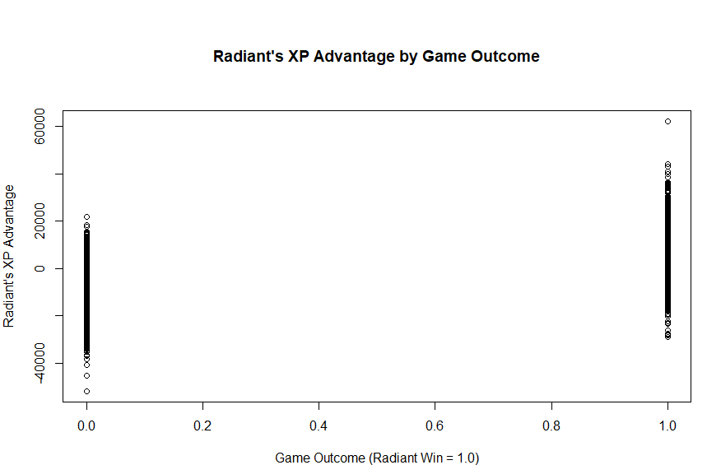

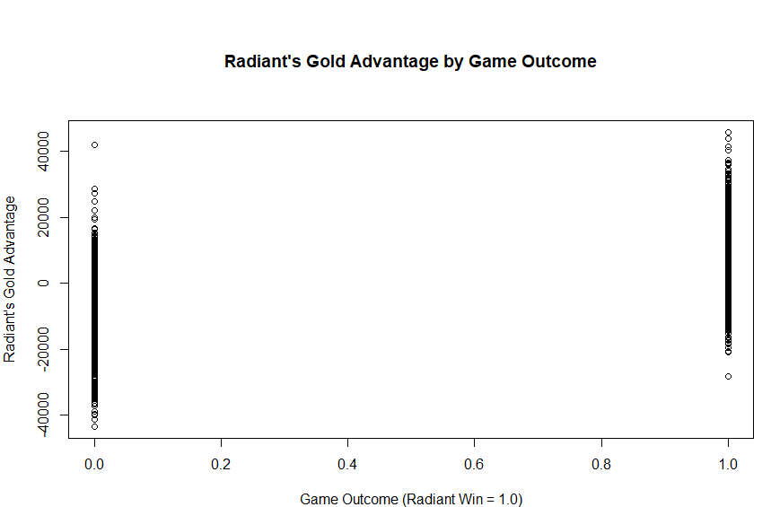

Fig. 5. Visualizations used to explore the second data set.

Just like the one from the first analysis, these plots have many data points that are clumped together. I used the boxplot to organize the data further.

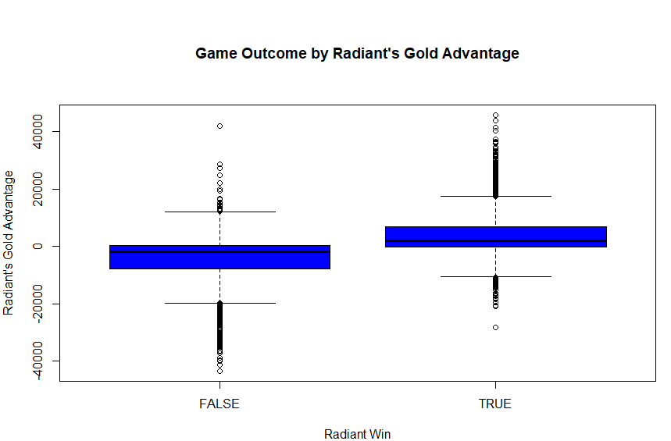

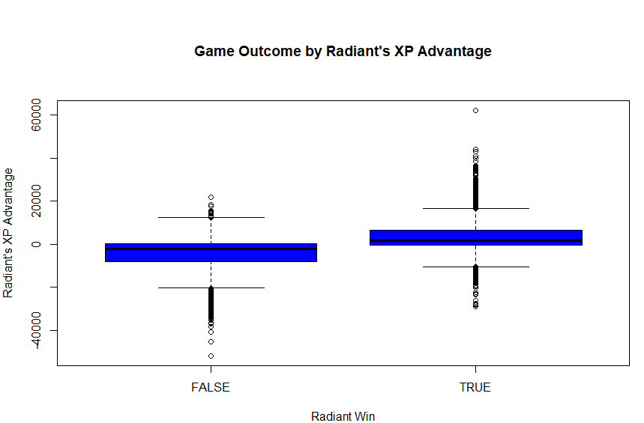

Fig. 6. Boxplot to enhance visualization for the second data set.

There seems to be a trend for both variables – each variable seems to be positively correlated with winning. There seems to be a lot of outliers, but when I counted them, there were less than 10% for each variable. Therefore, they seem like they could be good predictors.

**Part 5**

**Model the Data**

**5.1 Variables and type of model**

What I want to predict has two possible outcomes – “Win” or “Lose”. This is a categorial variable with 2 levels. My independent variables are continuous variables, gold and XP. Therefore, I decided to use logistic regression.

**5.2 Data partitioning**

I divided the training and test data set by 60% / 40%.

**5.3 Coefficients**

Here are the coefficients from the model:

Intercept: 1.528, *** (high significance; z value within 0 and 0.001)

Gold Advantage: 1.611, ***

XP Advantage: 7.829, ***

**5.4 Accuracy - training**

I applied the model to the training data set and compared the predicted outcome to the actual outcome. The prediction returns percentages of likelihood of Radiant winning for every game, so I set a threshold of winning at 50% to transform them into boolean values that can be compared to the actual outcomes. If the percentage is above 50%, it would predict “win”; if it is below 50%, it would predict “loss”.

|  |  |  |
| --- | --- | --- |
| Predicted\\Real | Win | Loss |
| Win(>50%) | Correct | Incorrect |
| Loss(<50%) | Incorrect | Correct |

Fig. 7. Chart for categorizing predictions.

The accuracy of this model was 72.7%. This is higher than guessing games at random, like flipping a coin (50% / 50% chance).

**5.5 Accuracy - test**

I applied the model to the test set. The accuracy for this set was 73.7%.

**Part 6**

**Results, visualized**

**6.1 3D Scatterplot of the actual and predicted results**

I plotted the predictor values and their corresponding actual outcome and predicted win chance values.

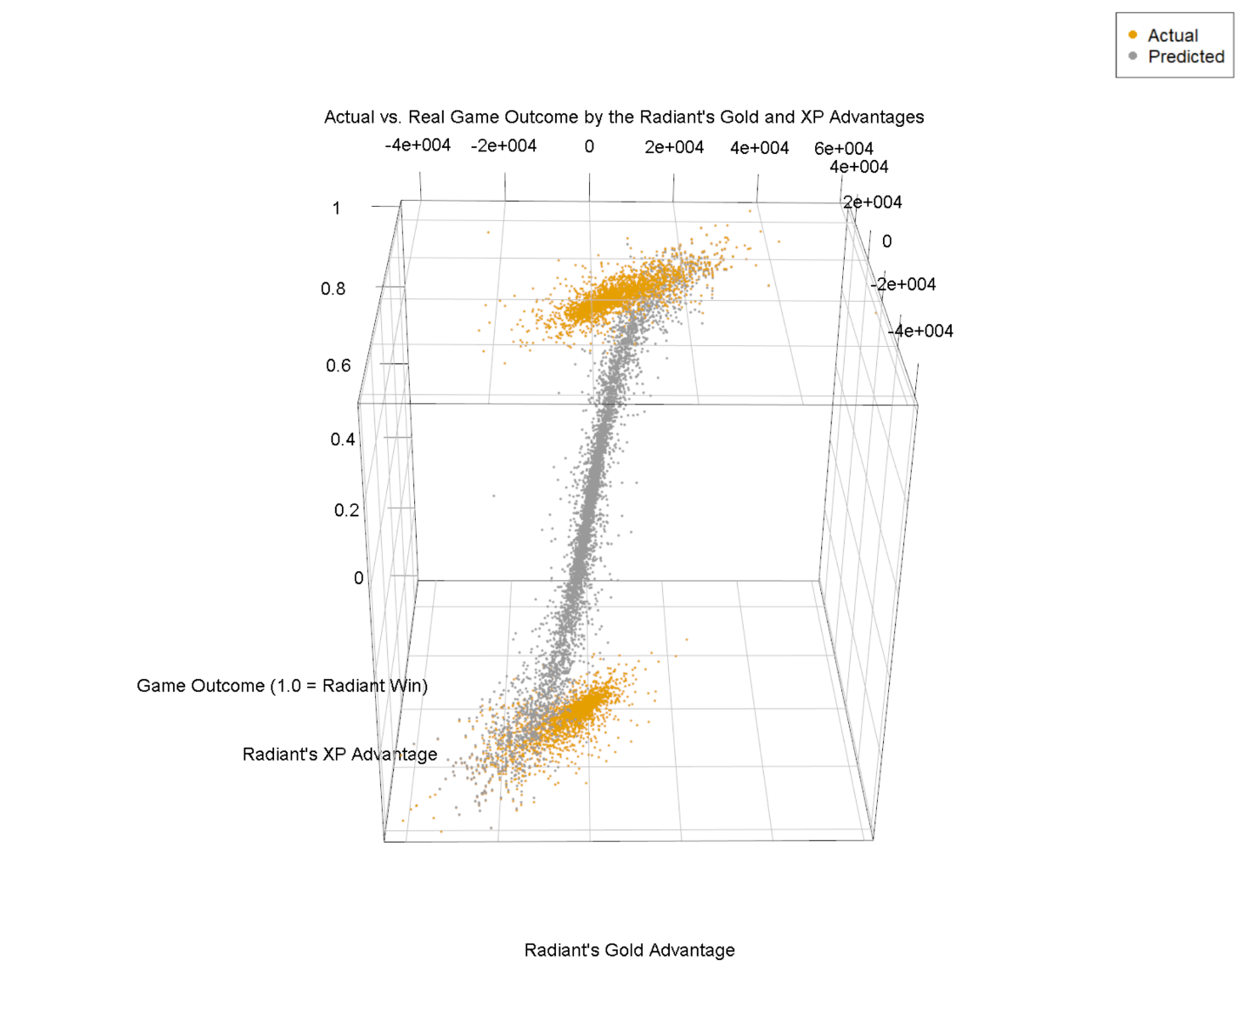

Fig 8.1. Actual vs. Predicted Game Outcome by the Radiant’s Gold and XP Advantages, View 1.

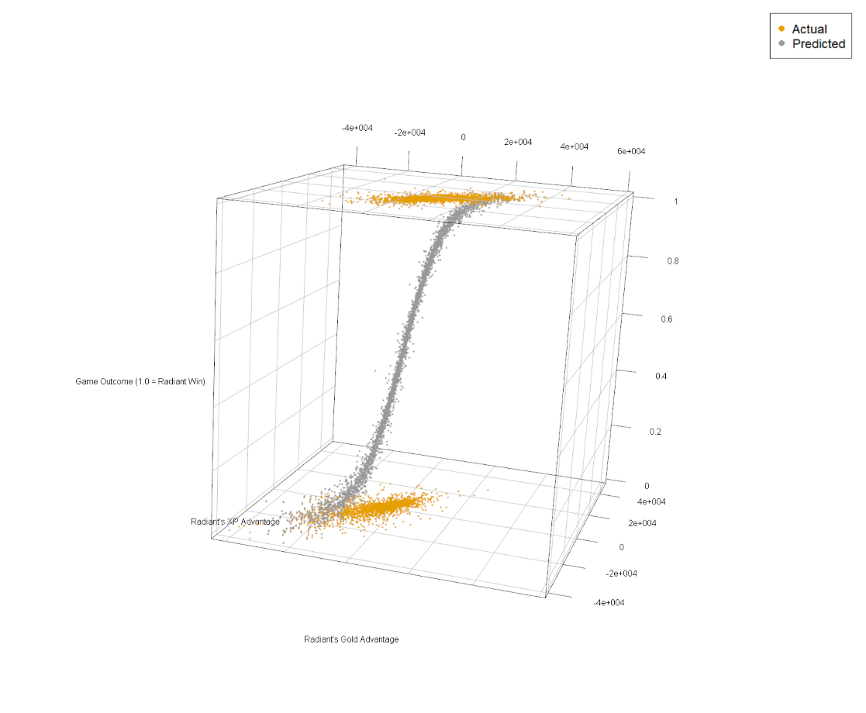

Fig 8.2. View 2.

The prediction points resemble a logistic regression curve. Its steepness in the middle as well as the closeness of the points on the end to the actual values denote its strength in accuracy.

Here is a visualization with the predictions grouped by the 50% threshold.

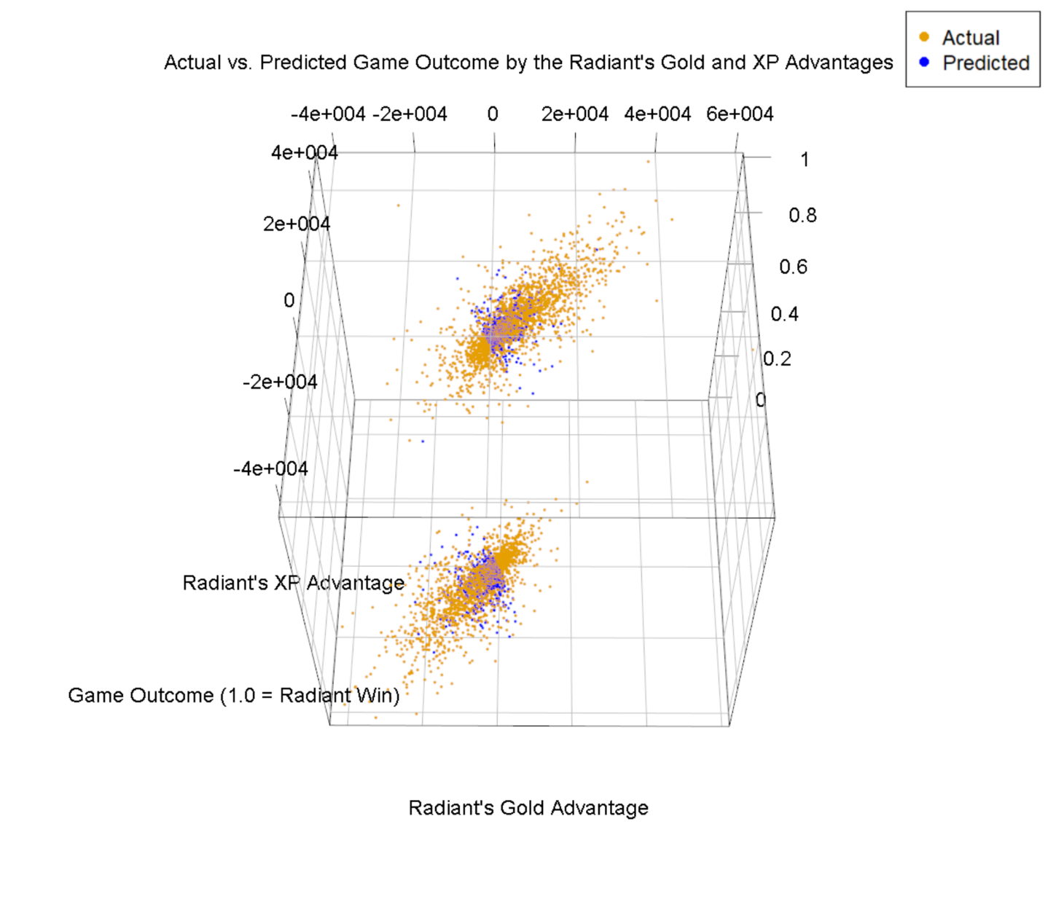

Fig 9. Actual vs. Predicted Game Outcome, classified by a 50% threshold, by the Radiant’s Gold and XP Advantages.

Note the overlap between the predicted and the actual values. This further attests to the accuracy of the model.

**6.2 Reflections**

Contrary to my first hypothesis, team composition score difference did not seem to be correlated with game outcome. This could be caused by my calculation method in which characters that can serve more roles contribute to better team composition score. A typical versatile character would get 4 to 7 points , contributing to a lower team composition score, while a single-role-centered character would get 1, contributing a higher team composition score. This may not accurately reflect the team composition strength in a game where players could carefully choose five single-role-centered characters with five different roles for a synergetic effect.

Acquiring more gold and XP than the other team was positively correlated with winning, as I had hypothesized. These must be pretty important factors in the game; players criticize others who “auto-hit”, or damage monsters without the intention to “last hit”, the killing blow that grants gold. In the professional leagues, they sometimes show these stats as a progression throughout the game, much like the assists, rebounds, and other stats in basketball.

**Part 7**

**Sources**

1. **Roles -- what they are**

<https://liquipedia.net/dota2/Hero_Roles>

1. **Roles -- for individual heroes**

<https://dota2.gamepedia.com/Phantom_Lancer>

1. **UCI Data repository with dota 2 games stats**

<https://archive.ics.uci.edu/ml/datasets/Dota2+Games+Results>

1. **Data from Kaggle**

<https://www.kaggle.com/c/mlcourse-dota2-win-prediction/data>